Lab - 4

1. **Exercise on retrieving records from a table.**   
   a. Find out the names of all the clients.

select name from CLIENT_MASTER;

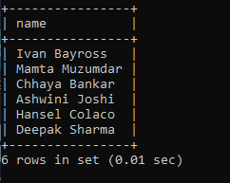  
b. Retrieve the entire contents of the Client_Master table.

select * from CLIENT_MASTER;

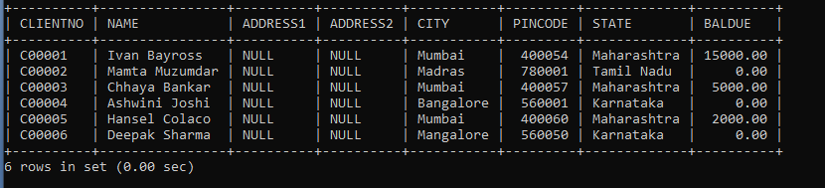  
c. Retrieve the list of names, city and the state of all the clients.

select name, city, state from CLIENT_MASTER;

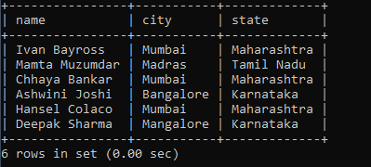

d. List the various products available from the Product_Master table.

select description from PRODUCT_MASTER;

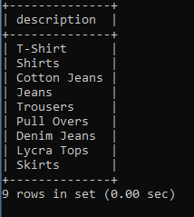  
e. List all the clients who are located in Mumbai.

select name from CLIENT_MASTER where city = 'Mumbai';

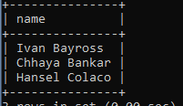

f. Find the names of salesman who have a salary equal to Rs.3000.

select salesmanname from SALESMAN_MASTER where SALAMT = 3000;

6.PNG

1. **Exercise on updating records in a table**   
   a. Change the city of ClientNo ‘C00005’ to ‘Bangalore’.

UPDATE CLIENT_MASTER SET CITY = 'Bangalore' WHERE CLIENTNO = 'C00005';

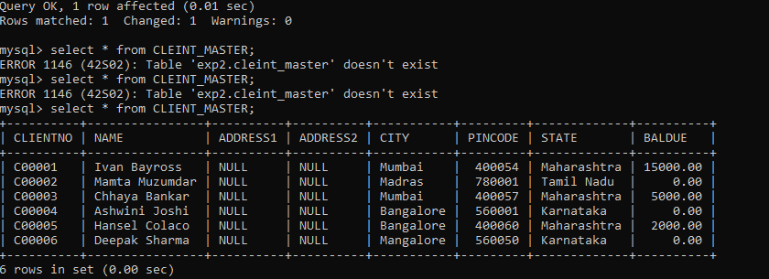  
b. Change the BalDue of ClientNo ‘C00001’ to Rs.1000.

UPDATE CLIENT_MASTER SET BALDUE = 1000 WHERE CLIENTNO = 'C00001';

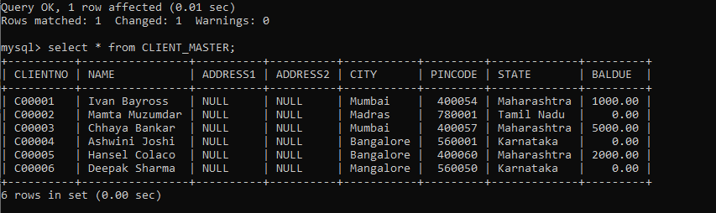  
c. Change the cost price of ‘Trousers’ to rs.950.00.

UPDATE PRODUCT_MASTER SET COSTPRICE = 950.00 WHERE DESCRIPTION = 'Trousers';

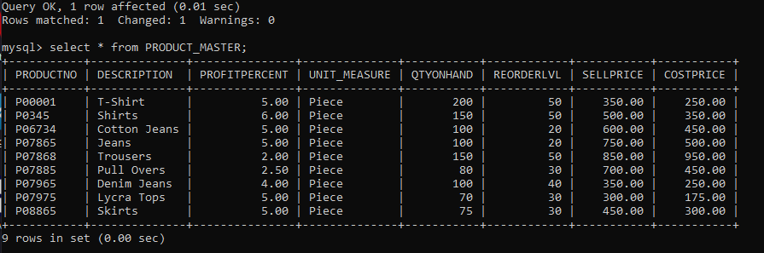  
d. Change the city of the salesman to Pune.

UPDATE SALESMAN_MASTER SET CITY = 'Pune';

9.PNG

1. **Exercise on deleting records in a table**   
   a. Delete all salesman from the Salesman_Master whose salaries are equal to Rs.3500.

**DELETE FROM SALESMAN_MASTER WHERE SALAMT = 3500;**



b. Delete all products from Product_Master where the quantity on hand is equal to 100.

DELETE FROM PRODUCT_MASTER WHERE QTYONHAND = 100;

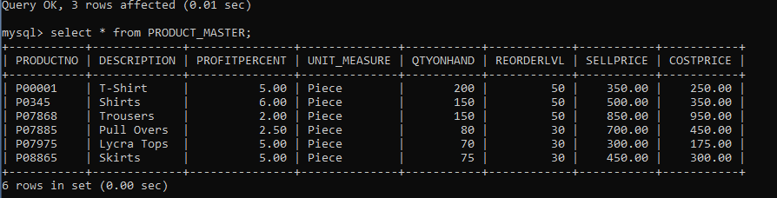

c. Delete from Client_Master where the column state holds the value ‘Tamil Nadu’.

DELETE FROM CLIENT_MASTER WHERE STATE = 'Tamil Nadu';

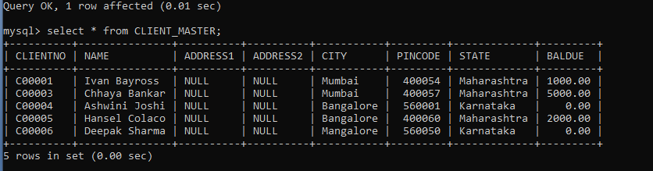

1. **Exercise on altering the table structure**   
   a. Add a column called ‘Telephone’ of data type integer to the Client_Master table.

ALTER TABLE CLIENT_MASTER ADD COLUMN TELEPHONE INTEGER;

13.PNG  
b. Change the size off SellPrice column in Product _Master to 10, 2.

ALTER TABLE PRODUCT_MASTER MODIFY COLUMN SELLPRICE DECIMAL(10, 2);

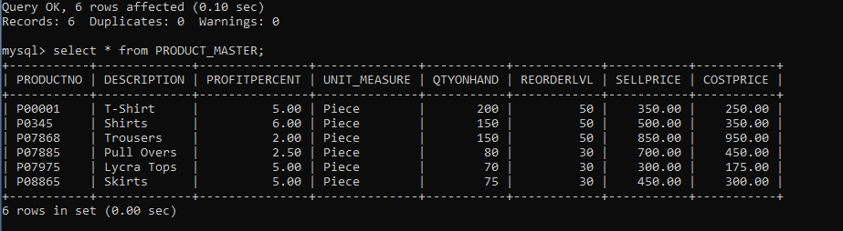

1. **Exercise on deleting the table structure along with the data**   
   a. Destroy the table Client_Master along with its data.

DROP TABLE CLIENT_MASTER;

